KYLE RAYNER

ksrayner@deakin.edu.au

Abstract

This document takes a look at a number of racing games in order to find commonalities in the Heads-Up Displays (HUD). Elements of the Heads-Up Displays in the racing games reviewed that are well executed will also be mentioned.

Research on heads-up Displays (HUD) for  
racing games

SIT378 – Team Project (B) – Execution and Delivery

Contents

Introduction 2

Findings 2

Video Games that were looked at 3

Assetto Corsa 3

Dirt Rally 2.0 3

Forza Horizon 5 4

Gran Turismo 7 4

iRacing 5

Mario Kart 8 Deluxe 5

Need for Speed Heat 6

Project Cars 2 6

Ride 4 7

Trackmania 2020 7

Conclusion 7

References 8

# Introduction

The purpose of this document is to discover commonalities in the Heads-Up Displays (HUD) between various racing games and also elements that I think are particularly well executed. The racing games that will be reviewed includes car racing games, motorbike racing games, serious racing games, casual racing games, Virtual Reality racing games and traditional racing games. Through conducting this research, I will be better prepared to create a Heads-Up Display for the Cycling Against Friends/Ghosts feature for the Virtual Reality version of it. The main objective here is to create a Heads-Up Display that feels familiar so that users can quickly get up & running with it while also implementing some new & unique elements so that it is distinguishable from what’s already out there. This document will present my findings and will also showcase all the video games that were taken into consideration.

# Findings

Below is a list of commonalities in the Heads-Up Displays in a number of racing games.

* If the user’s vehicle is in third person perspective, most of the time the speedometer or simply just the speed is located in the bottom-left of the Heads-Up Display. Some of the games that were looked at, had the speedometer/speed indicator in a different position. For example, Trackmania 2020 included the speed on the back of the vehicle.
* First person perspective racing games often designed the speedometer/speed indicator into the dashboard of the car in order to emulate real life.
* In most of the games that was reviewed, a mini-map or some other indication of the user’s progress was shown in the bottom-left or top-right of the Heads-Up Display.
* The majority of the time, some form of indicating the user’s position was located in the top-left of the Heads-Up Display.
* Often, if the track being played had multiple laps, a lap counter would be placed next to the user’s position indicator in the top-left of the Heads-Up Display.

Below is a list of interesting elements of the Heads-Up Displays from the games reviewed which I particular like.

* Trackmania 2020 included the speed on the back of the car. I think this is a really unique way of displaying that information and helps make the Heads-Up Display clean and minimalistic.
* Dirt Rally 2.0 included a progress bar on the left of the Heads-Up Display to showcase where the user is up to on the track. I really liked how they implemented this as it is different to all the other games that was reviewed.
* Several of the game’s reviewed included not only the position of the user but also included a list of several other racers both ahead and behind the user. I quite like how most of the games implemented this element.
* More often that not, a simple and minimalistic Heads-Up Display is preferred. Certain games have a really busy Heads-Up Display which I find distracting.

# Video Games that were looked at

Below is the list of games looked at in order to find commonalities between them when it comes to Heads-Up Displays. As you will notice, there is a lot of variety among them which helped in providing a general overview of Head-Ups Displays in racing games.

## Assetto Corsa

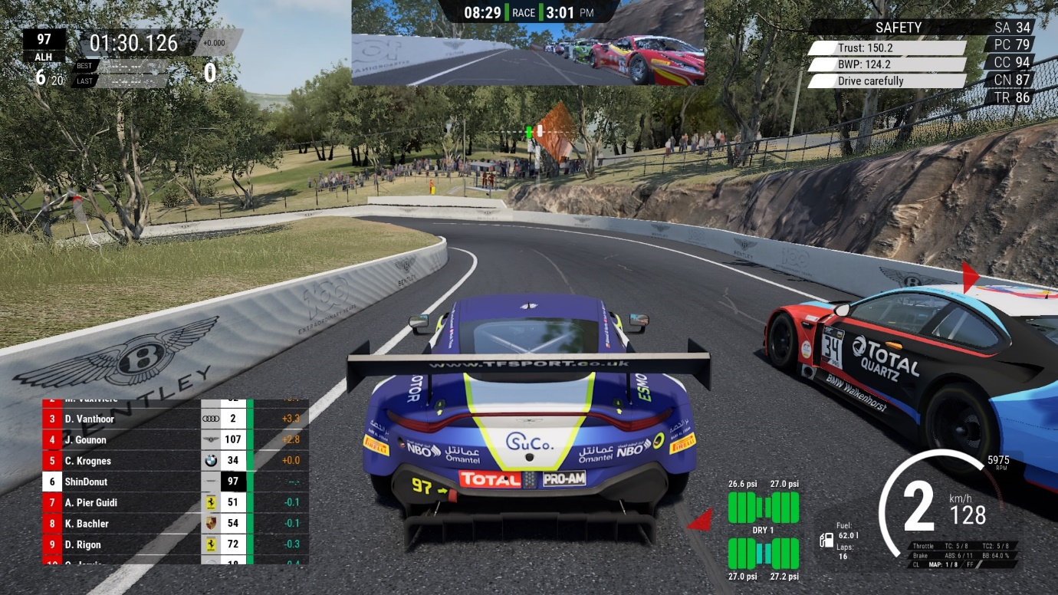

Figure – Screenshot of Assetto Corsa game by Mike (2020)

## Dirt Rally 2.0

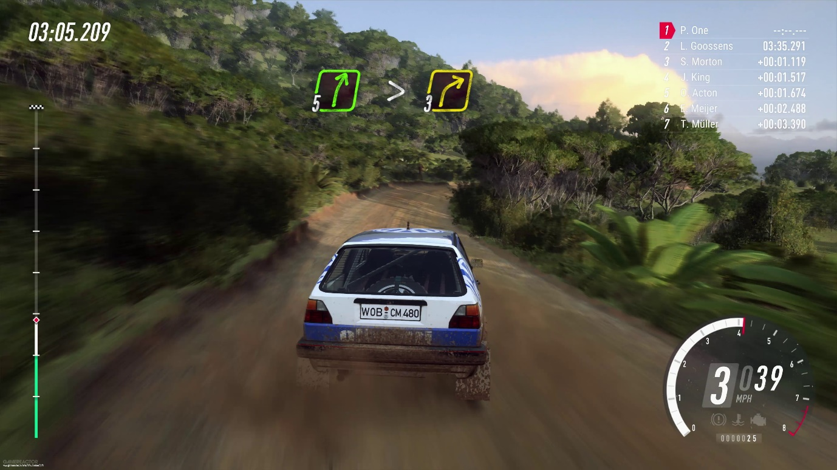

Figure – Screenshot of Dirt Rally 2.0 game by Orremark (2018)

## Forza Horizon 5

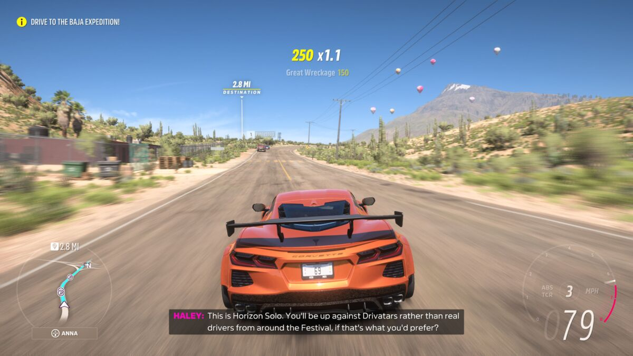

Figure – Screenshot of Forza Horizon 5 game by Bates (2021)

## Gran Turismo 7

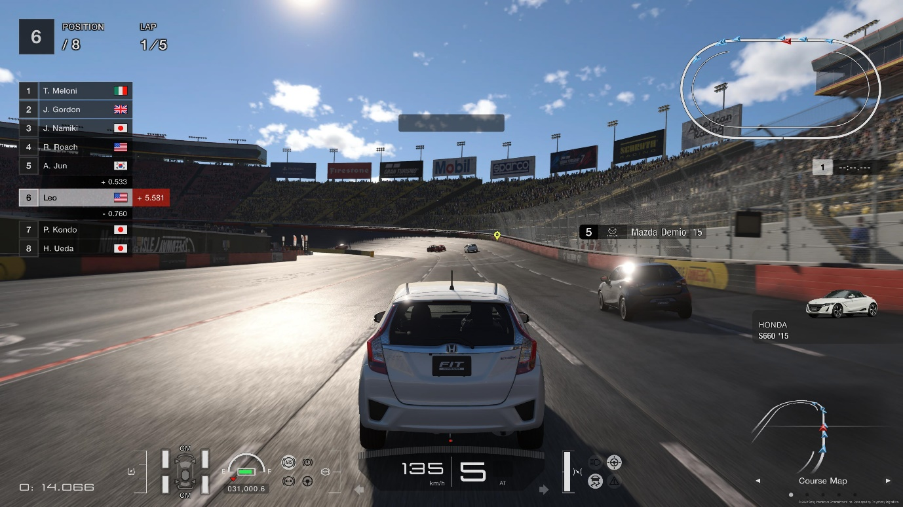

Figure – Screenshot of Gran Turismo 7 game by Faria (2022)

## iRacing

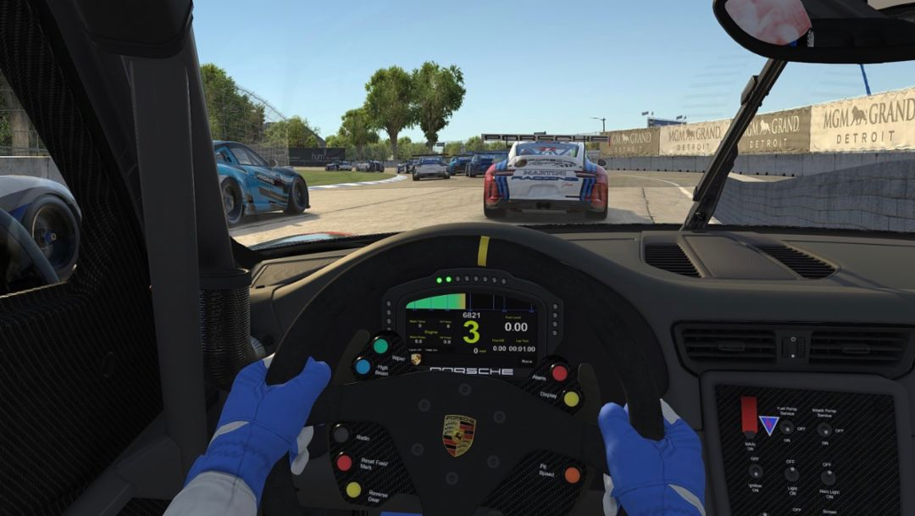

Figure – Screenshot of iRacing game by Newsroom (2019)

## Mario Kart 8 Deluxe

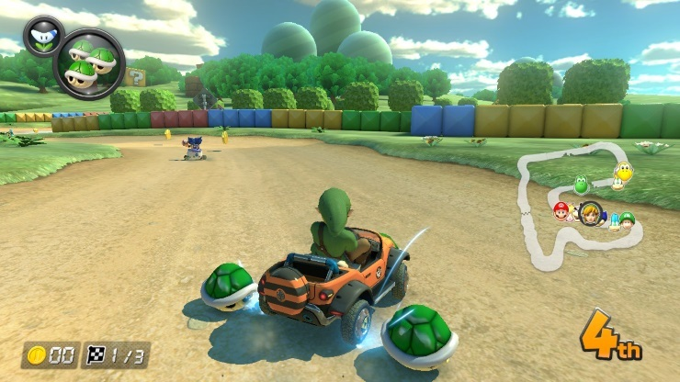

Figure – Screenshot of Mario Kart 8 Deluxe game by Greenwald (2017)

## Need for Speed Heat

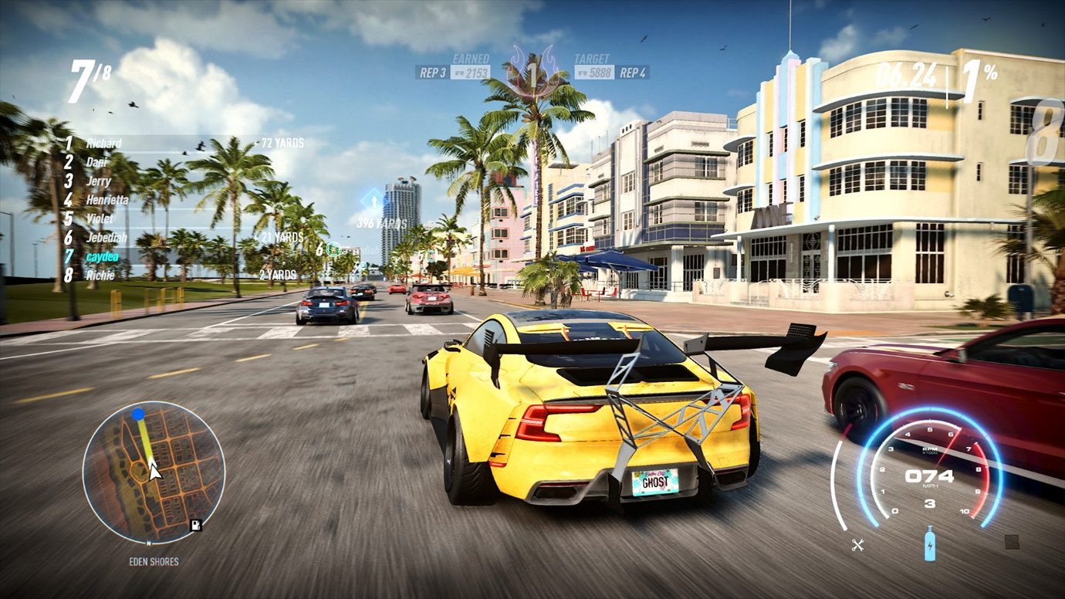

Figure – Screenshot of Need for Speed Heat game by Ghost Games (2019)

## Project Cars 2

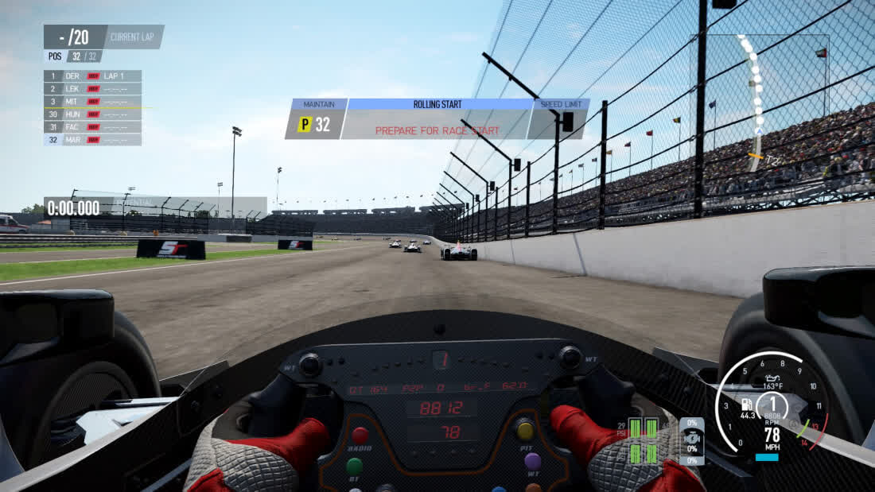

Figure – Screenshot of Project Cars 2 game by TechSpot (2017)

## Ride 4

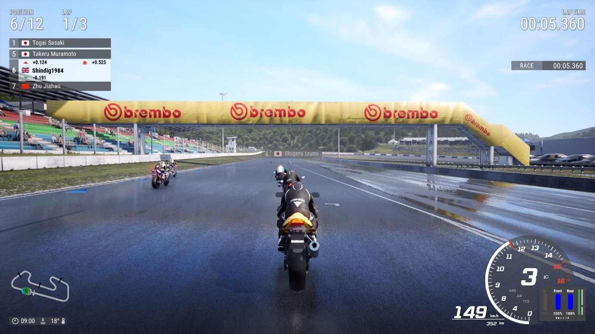

Figure – Screenshot of Ride 4 game by Mike (2019)

## Trackmania 2020

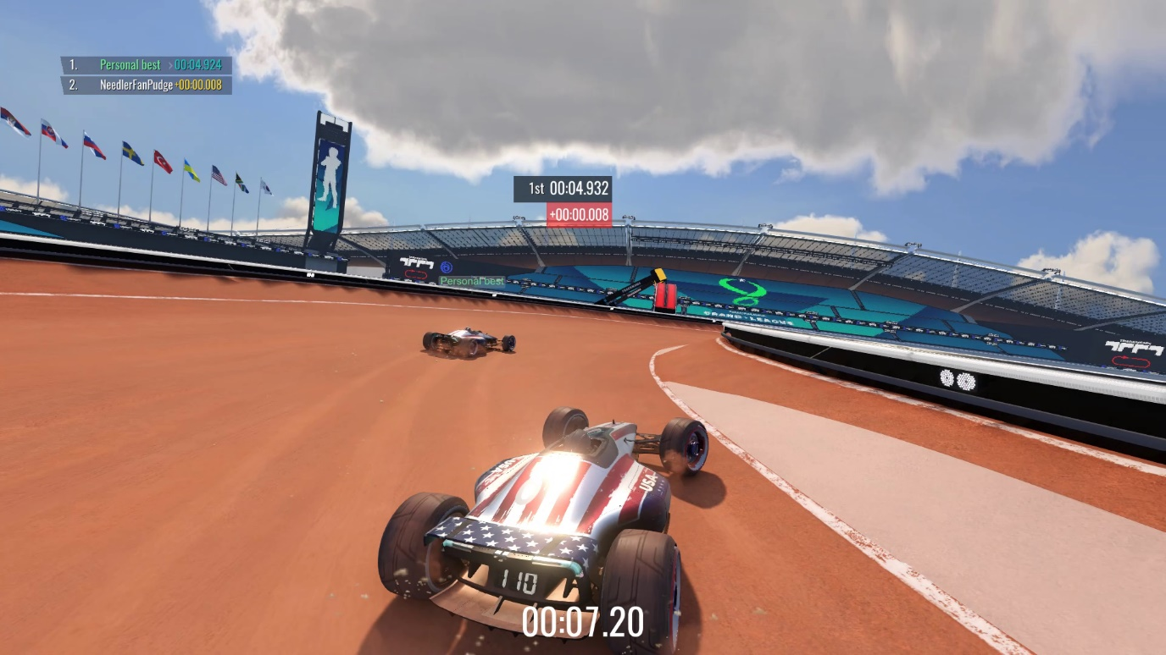

Figure – Screenshot of Trackmania 2020 game by Maria (2020)

# Conclusion

This document focussed on looking at a number of different racing games and finding commonalities in the Heads-Up Displays between them. Several commonalities were discovered along with revealing many elements that I found to be well executed/implemented. This research will be invaluable when it comes to designing the Heads-Up Display for the Cycling Against Friends/Ghost Feature for the Virtual Reality version of it.

# References

Bates A (2021) Can you Play Forza Horizon 5 Offline?, Cultured Vultures, accessed 25 November 2022. <https://culturedvultures.com/play-forza-horizon-5-offline/>

Codemasters (2019) Dirt Rally 2.0, Computer Program, Southam, England

Ghost Games (2019) Need for Speed Heat, Computer Program, Gothenburg, Sweden

Ghost Games (2019) Need for Speed Heat – Keys to the Map, Steam, accessed 25 November 2022. <https://store.steampowered.com/app/1281881/Need_for_Speed_Heat__Keys_to_the_Map/>

Greenwald W (2017) Mario Kart 8 Deluxe (for Nintendo Switch) Review, PCMag, accessed 26 November 2022. <https://www.pcmag.com/reviews/mario-kart-8-deluxe-for-nintendo-switch>

Faria L (2022) Review: Gran Turismo 7, Way Too Many Games, accessed 25 November 2022. <https://waytoomany.games/2022/03/10/review-gran-turismo-7/>

iRacing.com Motorsport Simulations (2008) iRacing, Computer Program, Chelmsford, MA

Kunos Simulazioni (2014) Assetto Corsa, Computer Program, ACI Vallelunga Circuit, Rome, Italy

Maria A S (2020) Trackmania [2020] – Review, IGN, accessed 26 November 2022. <https://za.ign.com/trackmania-2020/145067/review/trackmania-review>

Mike (2019) Ride 4 – PS4 Review, PlayStation Country, accessed 25 November 2022. <https://www.playstationcountry.com/ride-4-ps4-review/>

Mike (2020) Assetto Corsa Competizione – PS4 Review, PlayStation Country, accessed 25 November 2022. <https://www.playstationcountry.com/assetto-corsa-competizione-ps4-review/>

Milestone srl (2019) Ride 4, Computer Program, Milan, Italy’

Nadeo (2020) Trackmania 2020, Computer Program, Paris, France

Newsroom (2019) Porsche Esports Supercar becomes first global virtual one-make cup, Newsroom, accessed 25 November 2022. <https://newsroom.porsche.com/en/2019/motorsports/porsche-esports-supercup-virtual-one-make-cup-iracing-17348.html>

Nintendo EAD (2017) Mario Kart 8 Deluxe, Computer Program, Kyoto, Japan

Orremark K (2018) Dirt Rally 2.0 – Hands-On Impressions, Gamereactor, accessed 25 November 2022. <https://www.gamereactor.eu/dirt-rally-20-handson-impressions/>

Playground Games (2021) Forza Horizon 5, Computer Program, Leamington Spa, England

Polyphony Digital (2022) Gran Turismo 7, Computer Program, Tokyo, Japan

ghtly Mad Studios (2017) Project Cars 2, Computer Program, London, England

TechSpot (2017) Project Cars 2, TechSpot, accessed 25 November 2022. <https://www.techspot.com/products/pc-games/project-cars-2.162230/>